1. **Review Lecture About IS – LM and AS-AD Models**
   1. **Fixed Price IS – LM Modelwith Exogenous Money Supply and Investment – Saving Equilibrium.** 
      1. **Goods Market Equilibrium and IS Equation**
         1. **Consumption Function, Disposable Income and Marginal Propensity to Consume**
         2. **Investment Function**
         3. **Government Expenditures**
         4. **Deriation of IS Curveat Equilibrium Condition of Goods Market, Fiscal Multiplier and Budget**

**Linear Example for Determination of the Equilibrium Income**

**Derivation of Multiplier**

**Budget Balance**

**Slope of the IS Curve**

**Visual Derivation of IS Curve:**

* + 1. **Investment - Saving Equilibrium**
       1. **Saving – Investment Derivationof the IS Curve**
       2. **Paradox of Saving**
       3. **Saving Investment Relationship in an Open Economy**
    2. **Financial Market and Standard LM Equation**
       1. **Exogenous Money Supply and Money Creation Process.**

**Money and Bond Markets**

**Bond Price and Bond Yiels**

**Liquidity Preference Theory and Demand For Money:**

**Exogenous Money Supply or Exogenous Monetary Base**

**Money Multiplier – Monetary Base, Money Creation Process**

**Policy Tools of Central Bank to Manage Money Supply**

**Fourth Policy Tool of Central Bank: Interest on Excess Reserves**

**Negative Interest Rates on Excess Reerves**

**Determining the Interest Rate Central Bank can determine money supply**

**Determining the Interest Rate Central Bank can determine monetary base (central bank money)**

**Loanable Funds Theory and an Alternative Theory for Interest Rate Determination**

**Two Alternative Theories for Interest Rate Detemination: Liquidity Preference and Loanable Funds**

**Money Market Under the Condition of Liquidity Trap**

* + - 1. **Deriation of LM Curve at Equilibrium Condition of Money Market**

**Slope of the LM Curve**

* + 1. **Goods and Money Market Equilibrium IS-LM Model:**
       1. **Fiscal and Monetary Multipliers in IS – LM Model**

**Crowding Out**

**About the Size of Fiscal Multiplier**

**Krugman’s Three Ideas About Liquidity Trap and Crowding Out:**

* + - 1. **Analysis of Policy Implications With IS – LM Model**
      2. **Alternative IS – LM Model with Policy Interest Rate**
      3. **Finance Motive for Money Demand and Interaction Between the IS an LM Curves**
      4. **IS – LM Model with Credit (Loanable Funds Market) Markets: *Bernanke Blinder Model***

**1. Review Lecture About IS – LM and AS-AD Models**

* 1. **Fixed Price IS – LM Modelwith Exogenous Money Supply and Investment – Saving Equilibrium.**

The first step in building a model is determining the **endogenous** and **exogenous** variables. When a variable is modeled as **exogenous**, it is assumed that these variables are determined by an authority that is excluded from the model. In the standard IS-LM framework, **government expenditures** and **money supply** are treated as exogenous variables. The main **endogenous** variables of the system are **income** and **interest rate**.

We are going to construct two dimensional plane whose axes are income and interest rate (endogenous variables) respectively. Determining equilibrium values of endogenous variablesrequires two independent equations that indicate equilibrium conditions of the commodity and the money market.

* + 1. **Goods Market Equilibrium and IS Equation**

In standard IS – LM models aggregate demand $AD$ is the sum of real consumption $C$ spending by households which is positively related to real disposable (after tax) income, real investment $I$ spending by firms which is negatively depends on real interest rate $r$ and real government spending $G$ which is determined exogenously by government(Scarth, 1988, p. 23).

$$AD=C+I+G$$

In open economy export and import should be added into the definition of aggregate demand

* + - 1. **Consumption Function, Disposable Income and Marginal Propensity to Consume.**

Real consumption spending by households $C$ is positively related to real disposable (after tax) income [1]

**Marginal Propensity to Consume MPC:**The term ***MPC***, the **marginal propensity to consume**, reflects the change in consumption expenditure that results from an additional dollar of **disposable income (***sometimes it could be income only)* . Keynes assumed that *mpc* was a constant between the values of 0 and 1. If, for example, a $1.00 increase in disposable income leads to an increase in consumption expenditure of $0.60, then *mpc* = 0.6. ***MPC***is the change in consumer spending divided by the change in disposable income or under the limit conditions it is derivative of cosumer spending respec to disposable income.

Because consumers normally spend part but not all of an additional dollar of disposable income, ***MPC***is a number between 0 and 1. ***MPS,*** is the fraction of an additional dollar ofdisposable income that is saved. *MPS* is equal to 1 - *MPC.*With the assumption of no taxes and no international trade.

$$MPC=\frac{∂C}{∂Y^{d}} 0<MPC<1 MPS=1-MPC 0<MPS<1$$

# How does the marginal propensity to consume in the United States compare to other countries?

By [Sean Ross](http://www.investopedia.com/contributors/53893/) | June 4, 2015.

The [**marginal propensity to consume**](http://www.investopedia.com/ask/answers/050115/how-do-you-calculate-marginal-propensity-consume.asp), or the ratio of the change in aggregate consumption compared to the change in aggregate income, in the United States tends to be higher than many other countries around the world. **This also means Americans tend to save less than the citizens of other countries**. Economists and statisticians often approximate the **marginal propensity to consume in the U.S. at between 90 and 98%**; this is different than the **average propensity**to consume, which is lower in the U.S. than many countries.**This high level of consumption, relative to new income, is a consistent phenomenon, at least since the low-interest rate policies of the 1990s, though consumption habits did dip during the great recession of 2007-2008.** In fact, marginal propensity to consume figures actually undersell the spend-heavy habits of Americans because they ignore credit cards and [home equity lines of credit](http://www.investopedia.com/articles/mortgages-real-estate/11/helocs-can-hurt-you.asp).

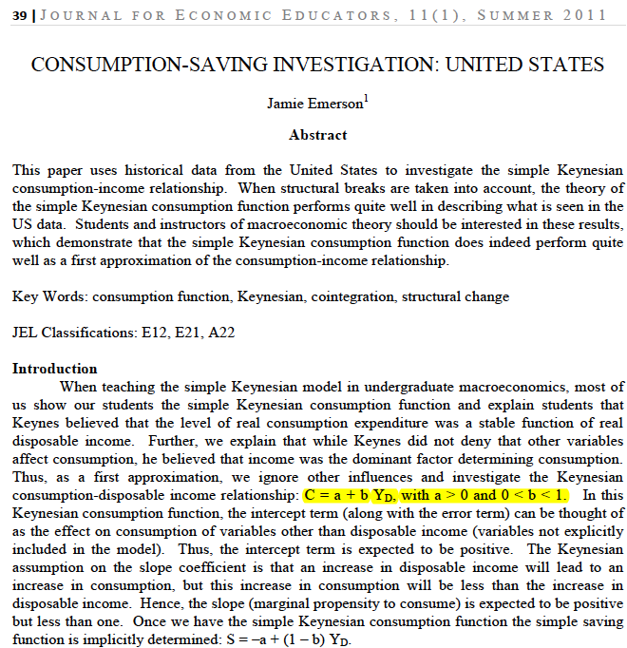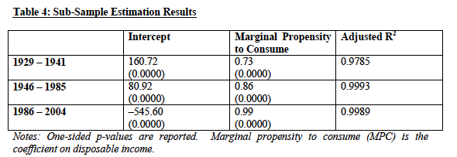

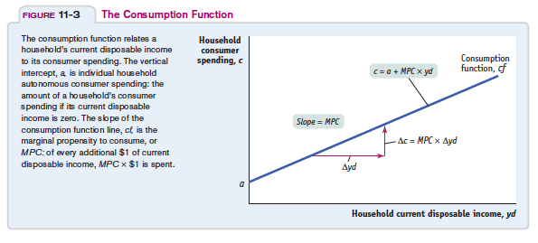

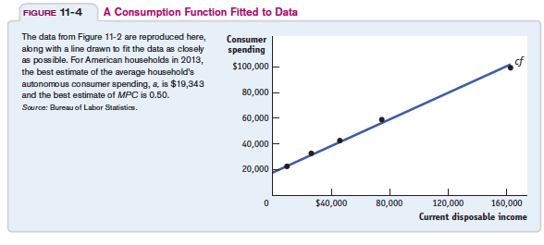



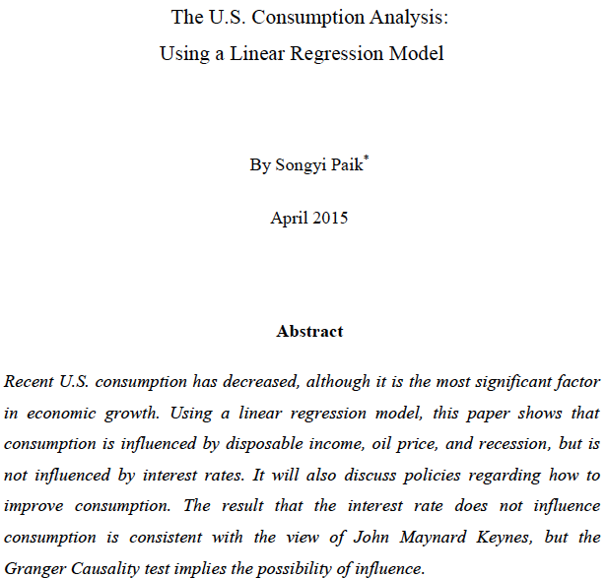

The **MPC is higher in the case of poor and ordinary people** than it is for the extremely wealthy. The greater a person’s wealth, the more of their basic human needs will have already been met, and the greater their tendency to save a proportion of their income in order to provide for future will be.   
  
The marginal propensity to save of the richer classes is greater than that of the poorer classes. Thus it follows that **if the government want to increase economic demand, then purchasing power must be transferred from the richer classes** (with their lower propensity to consume) **to the poorer classes** (with their higher propensity to consume).

* + - 1. **Investment Function**

Real investment $I$ spending by firms which is negatively depends on real interest rate $r$. Businesses makeinvestments in physical capital (machines and factories) as long as they expect to earnmore from the physical capital than the **interest cost of a loan to finance the investment**

Here it is sufficient to note that the real interest rate measures the true cost of borrowing and, thus, determines the quantity of investment. We can summarize this discussion with an equation relating investment I to the real interest rate r:

$$I\left(\underset{-}{\underbrace{r}}\right)$$

Figure shows this investment function. It slopes downward, because as theinterest rate rises, the quantity of investment demanded falls.

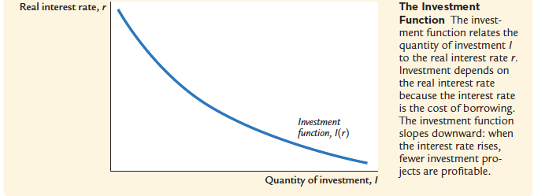

**Investment and Sales:** The level of sales. Consider a firm facing an increase in sales and needing to increase production. To do so, it may need to buy additional machines or build an additional plant. In other words, it needs to invest. A firm facing low sales will feel no such need and will spend little, if anything, on investment. Sales and production are positively correlated. As a result, ***Y***denotes sales, and it also denotes production. $$I\left(\underset{+}{\underbrace{Y}},\underset{-}{\underbrace{r}}\right)$$

The positive sign under *Y* indicates that an increase in production (equivalently, anincrease in sales) leads to an increase in investment. The negative sign under the interest rate *r*indicates that an increase in the interest rate leads to a decrease in investment.

Keynes considered the level of the real interest rate for investments a key determinant of planned investment spending.To understand Keynes’s reasoning, we need to recognize that businesses makeinvestments in physical capital (machines and factories) as long as they expect to earn more from the physical capital than **the interest cost of a loan to finance the investment**. When real interest rates and hence the cost of borrowing are low, business firms are more likely to undertake an investment in physical capital, and investment spending will increase. Keynes also believed that planned investment spending is heavily influenced by **business expectations about the future**. Businesses that are optimistic about future profit opportunities are willing tospend more, while pessimistic businesses cut back their spending. Thus Keynes posited that there is a component of planned investment spending, which he called autonomous investment, *I*, that is completely exogenous (unexplained by variables in his model such as output or interest rates). Investment spending, which are influenced by emotional waves of optimism and pessimism—factors he labeled “animal spirits.”Combining Keynes’ two factors that drive investment leads toan investment function, which describes how planned investment spending is related tothe real interest rate for investments and autonomous investment. We write it as follows:





* + - 1. **Government Expenditures**

The third component of demand in our model is government spending, *G*. Togetherwith taxes *T*, *G* describes **fiscal policy**—the choice of taxes and spending by the government. It is supposed that *G* isexogenous. *T* can be described as a function of income or it can be taken exogenous like *G*or can be expressed a kind of combination of both of them like ***T* = *T* + *t Y***

* + - 1. **Derivation of IS Curve at Equilibrium Condition of Goods Market, Fiscal Multiplier and Budget.**

Change in income over time is derived by difference of aggregate demand and income.

$$\frac{dY}{dt}=α\left[AD-Y\right] 0<α<1$$

Equilibrium condition of commodity market is represented by IS equation.

$$\dot{Y}=\frac{dY}{dt}=0→Y=C+I+G$$

**Linear Example for Determination of the Equilibrium Income.**



**An increase in government expenditure causes the income to increase through the multiplier effect.****Multiplier:** 

The **government expenditure multiplier** is the magnification effect of a change in government expenditure on goods and services on aggregate demand, which increases real GDP.

According to assumption of the  multiplier greater than one

For example: if  then multiplier 

For example: if  then multiplier 

For example: if  then multiplier 

***Any increase in government expenditure leads to a bigger increase in national income.***

**Derivation of Multiplier**



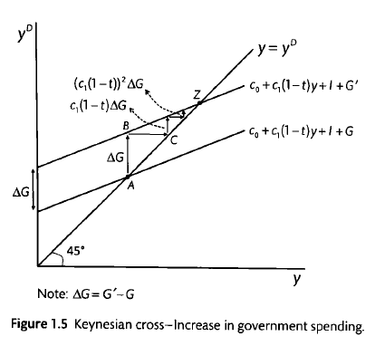

**Budget Balance**

****Budget



***Any increase in government expenditure leads to a decrease in budget.***

$$\underset{F}{\underbrace{Y-C-I}}=G$$

$$dF=\frac{∂F}{∂Y}dY+\frac{∂F}{∂r}dr=0$$

$$dF=\left(1-\frac{∂C}{∂Y}\right)dY-\left(\frac{∂C}{∂r}+\frac{∂I}{∂r}\right)dr=0$$

**Slope of the IS Curve:**

$$\frac{dr}{dY}=-\frac{\frac{∂F}{∂Y}}{\frac{∂F}{∂r}}=-\frac{\left(\underset{+}{\underbrace{1-\frac{∂C}{∂Y}}}\right)}{-\left(\underset{-}{\underbrace{\frac{∂C}{∂r}+\frac{∂I}{∂r}}}\right)}<0$$

According to definition of disposable income;

$$Y^{d}=Y-T$$

If the tax is ignored or exogenously determined in order to satisfy the simplicity, for example it can be assumed that government imposes tax on private sector as much as its expenditures $G=T$ so $\frac{∂Y^{d}}{∂Y}=1$

$$\frac{∂C}{∂Y}=\frac{∂C}{∂Y^{d}}\frac{∂Y^{d}}{∂Y}=\frac{∂C}{∂Y^{d}}=0<MPC<1$$

If the tax revenue is determined as a fix ratio of income $T=tY$ then $\frac{∂Y^{d}}{∂Y}=1-t$



$$\frac{∂C}{∂Y}=\frac{∂C}{∂Y^{d}}\frac{∂Y^{d}}{∂Y}=0<MPC\left(1-t\right)<1$$

$$0<\frac{∂C}{∂Y}<1→1-\frac{∂C}{∂Y}>0$$

**Visual Derivation of IS Curve:**



**AD**

**AD=C+I+G, Y**



**AD**

**AD**

**AD=C+I+G, Y**



**AD=C+I+G, Y**

**AD**

**AD**

* + 1. **Investment - Saving Equilibrium**

Providing of equilibrium condition of the commodity market in next equation implies the **saving investment balance**.

$$Y=C+I+G$$

$S$ indicates national savings

$$S=\underset{S^{P}}{\underbrace{Y-T-C}}+\underset{S^{G}}{\underbrace{T-G}}$$

$$S=Y-C-G$$

Consideration of equations requires saving investment balance.

* + - 1. **Saving – Investment Derivationof the IS Curve**



* + - 1. **Paradox of Saving:**

$$Y=C+I+G$$

$$Y-T=C+I+G-T$$

$$Y-T-C=I+\left(G-T\right)$$

$$S^{P}=I+\left(G-T\right)$$



Disposable income can be saved or consumed by households.

$$Y-T=C+S$$

Suppoes that consumption is a linear function of income

$$C=a+b(Y-T)$$

Corresponding saving can be expressed anotjer increasing function of disposable income.

$$S=Y-T-C=Y-T-a-b\left(Y-T\right)=-a+(1-b)\left(Y-T\right)$$

$$S=-a+(1-b)\left(Y-T\right)$$

Suppose that investment, government expenditures and tax don’t change

$$I=\overline{I}, G=\overline{G} , T=\overline{T}$$

If autonomous consumption decreases from $a$ to 0 then autonomous saving increases.

$$C_{1}=a+b\left(Y_{1}-\overline{T}\right)C_{2}=b\left(Y_{1}-\overline{T}\right)$$

$$S_{1}=-a+\left(1-b\right)\left(Y_{1}-\overline{T}\right)S_{2}=\left(1-b\right)\left(Y_{?}-\overline{T}\right)$$

But decrease in consumption causes decrease in equilibrium value of income too.

$$Y_{1}=C+I+G=a+b\left(Y_{1}-\overline{T}\right)+\overline{I}+\overline{G}$$

$$\left(1-b\right)Y_{1}=a-bT+\overline{I}+\overline{G}$$

$$\overline{Y_{1}}=\frac{1}{1-b}\left(a-b\overline{T}+\overline{I}+\overline{G}\right)$$

$$Y_{2}=C+I+G=b\left(Y_{2}-\overline{T}\right)+\overline{I}+\overline{G}$$

$$\overline{Y_{2}}=\frac{1}{1-b}\left(b\overline{T}+\overline{I}+\overline{G}\right)$$

$$S_{1}=-a+\left(1-b\right)\left(Y_{1}-\overline{T}\right)=-a+\left(1-b\right)\left(\frac{1}{1-b}\left(a-b\overline{T}+\overline{I}+\overline{G}\right)-\overline{T}\right)$$

$$S_{1}=-a+a-b\overline{T}+\overline{I}+\overline{G}-\left(1-b\right)\overline{T}=\overline{I}+\overline{G}-\overline{T}$$

$$S_{1}=\overline{I}+\overline{G}-\overline{T}$$

$$S_{2}=\left(1-b\right)\left(Y_{2}-\overline{T}\right)=\left(1-b\right)\left(\frac{1}{1-b}\left(b\overline{T}+\overline{I}+\overline{G}\right)-\overline{T}\right)$$

$$S_{2}=b\overline{T}+\overline{I}+\overline{G}-\left(1-b\right)\overline{T}=\overline{I}+\overline{G}-\overline{T}$$

$$S_{2}=\overline{I}+\overline{G}-\overline{T}$$

Although people want to save more at a given level of income, their income decreases by an amount such that their saving is unchanged. This means that as people attempt to save more, the result is both a decline in output and unchanged saving.

* + - 1. **Saving Investment Relationship in an Open Economy**

$$Y=C+I+G+NX$$

$$S=\underset{S^{P}}{\underbrace{Y-T-C}}+\underset{S^{G}}{\underbrace{T-G}}$$

$$S=Y-C-G$$

Consideration of equations requires saving investment balance.



* + 1. **Financial Market and Standard LM Equation**
       1. **Exogenous Money Supply and Money Creation Process.**

**Money and Bond Markets**

*Money*, as $M1$ which you can use for transactions, pays no interest. In the real world,there are two types of money: **currency**, $CU$ coins and bills*in the hands of the nonbank public*, and **checkable (***the bank deposits on which you can write checks or use a debit card*) or **demanddeposits**, (*component includes business checking accounts that do not pay interest as well*) $D^{C}$. The sum of currency, checkable and demand deposits is called **M1**. The narrowest measure of money, **M1**, includes only the most liquid assets. (*Currency in the vaults of banks and ATMs are not included in* ***M1*)**To make our analysis simple for one moment we think just **currency**.

Economists define **money** as an asset that is generally accepted in payment for goods and services or in the repayment of debts. Because checks are also accepted as payment for purchases, deposits in checking accounts are also considered money. Even **deposits in savings accounts $D^{T}$** can function as Money in the form of $M2$ if they can quickly and easily be converted into currency or checking account deposits.

**Bonds** pay a positive interest rate, *i*, but they cannot be used for transactions. In the real world, there are many types of bonds and other financial assets, each associated with a specific interest rate. For the time being, we will also ignore this aspect of reality and assume that there is just one type of bond and that it pays, *i*, the rate of interest.

The **M2** monetary aggregate includes all of M1, plus several less liquid asset types, such as time deposits.

***According to Central Bank of the Republic of Turkey***

****M1=Currency in Circulation + Demand Deposits (TRY, FX)**

$$M^{S}=M1=CU+D^{C}$$

**M2=M1 + Time Deposits (TRY, FX)**

$$M^{S}=M2=CU+\underset{D}{\underbrace{D^{C}+D^{T}}}$$

**Liquidity Preference Theory and Demand For Money:**

John Maynard Keynes developed a theory of money demand that he described as ***liquidity preference theory***that carefully distinguishes between nominal quantities and real quantities[2].

Keynes reasoned that when people decide how much money they want to hold (demand), they consider **real money balances**, the quantity of money in real terms. In this model, demand for real money balances $\frac{M^{D}}{P}$ depends on real income, $Y$, and the nominal interest rate, $i$ (it will be renamed as $i^{B}$ later as an interest rate of bonds).The demand for real money balances is assumed to be positively related to real income and negatively related to the **nominal interest** rate (Shone, 2002, p. 432).We present Keynes’s liquidity preference theory in equationas follows:

$$\frac{M^{D}}{P}=L\underset{-,+}{\underbrace{\left(i,Y\right)}}$$

We refer to this equation as the **liquidity preference function or money demand function**: The minus sign below*i* means that as the nominal interest rate, *i*, rises, the demand for real money balancesfalls; the plus sign below *Y* means that as income, *Y*, rises, the demand for realmoney balances also rises.

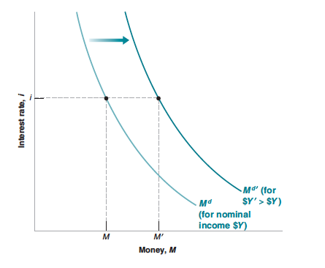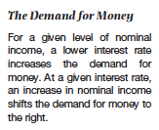

Why would the demand for real money balances have a negative relationship with the nominal interest rate *i*? The concept of **opportunity cost** of holding money *rather than alternative assets such as* ***bonds*** is the nominal interest paid on bonds. As the interest rate *i* rises, it becomes morecostly to hold money instead of bonds—that is, the opportunity cost rises— and the quantity of money demanded falls.

Real money balances are positively related to income for two reasons.

* As income rises, households and firms conduct more transactions and so keep more money on hand to make purchases.
* Higher incomes make households and firms wealthier, and the wealthy tend to hold larger quantities of all financial assets, including money.

**Bond Price and Bond Yields**

We have focused so far on the interest rate on bonds. In fact, what is determined in bondmarkets are not interest rates, but bond prices. The two are however directly related.

**Bonds that promise a payment of a given number of dollars, say $100, a year from now**,bonds issued by the government promising payment in a year (or less are called Treasury bills or T-bills) Let the price of a bond today be $\$P_{B}$, if you buy the bond today and hold it for a year, the **rate ofreturn** on holding the bond for a year is its interest rate

$$i^{B}=\frac{\$100-\$P_{B}}{\$P_{B}}$$

***The higher the price of the bond, the lower the interest rate.***

If we are given the interest rate, we can figure out the price of the bond using the same formula. Reorganizing the formula above, the price today of a one-year bondpaying $100 a year from today is given by.

$$i^{B}\$P_{B}=\$100-\$P_{B} →\left(1+i^{B}\right)\$P_{B}=\$100$$

$$\$P_{B}=\frac{\$100}{\left(1+i^{B}\right)}$$

If the interest rate is positive, the price of the bond is less than the finalpayment. The higher the interest rate, the lower the price today. You may hear that “bond markets went up today.” This means that the prices of bonds wentup, and therefore that interest rates went down.

**Exogenous Money Supply or Exogenous Monetary Base**

It is assumed that the supply of money is **exogenously** set by the Central Bank.If the central bank is able to control the money supply, the money supply is “exogenous,” and the money supply curve is vertical.



**How does the Central Bank can change the money supply?**

In modern economies, the way central banks typically change the supply of money is by **buying or selling bonds in the bond market**. If a central bank wants to increase the amount of money in the economy, it buys bonds and **pays for them by creating money**. If it wants to decrease the amount of money in the economy, it sells bonds and removes from circulation the money it receives in exchange for the bonds. These actions are called **open market operations.** To understand what open market operations do, it is useful to start with the balance sheet of the central bank. According to simplest explanation the assets of the central bank are the bonds it holds in its portfolio. Its liabilities are the stock of money in the economy. Open market operations lead to equal changes in assets and liabilities.

If the central bank buys, say, $1 million worth of bonds, the amount of bonds it holds is higher by $1 million, and so is the amount of money in the economy. Such an operation is called an **expansionary open market operation** , because the central bank increases (expands ) the supply of money. If the central bank sells $1 million worth of bonds, both the amount of bonds held by the central bank and the amount of money in the economy are lower by $1 million. Such an operation is called a contractionary open market operation , because the central bank decreases (contracts) the supply of money.

|  |  |
| --- | --- |
|  |  |

Consider first an expansionary open market operation, in which the central bankbuys bonds in the bond market and pays for them by creating money. As the central bankbuys bonds, the demand for bonds goes up, increasing their price. Conversely, the interestrate on bonds goes down. Note that by buying the bonds in exchange for money that itcreated, the central bank has increased the money supply.Consider instead a contractionary open market operation, in which the central bankdecreases the supply of money. This leads to a decrease in their price. Conversely, the interestrate goes up. Note that by selling the bonds in exchange for money previously heldby households, the central bank has reduced the money supply.This way of describing how monetary policy affects interest rates is more intuitive.By buying or selling bonds in exchange for money, the central bank affects the price ofbonds, and by implication, the interest rate on bonds.

**Money Multiplier – Monetary Base, Money Creation Process**

**Actually Central Bank can not determine the money supply exactly. It can control or manage the money supply through the monetary base which is constituted by assets or liabilities of the Central Bank.**

The nominal domestic money supply, $M^{S}$, equals **money multiplier $μ$**times **monetary base**(central bank money) $MB$

$M^{S}=μMB$

**Monetary base can be defined from the assets or the liabilities of the central bank**. In a closed economy assets of the central bank includes **central bank loans to banking sector $L^{CB}$** (*Discount loans. The Fed can provide reserves to the banking system by making discount loans to banks. An increase in discount loans can also be the source of an increase in the money supply. The interest rate is charged banks for these loans called the discount rate)*and **governments bonds $B^{CB}$** held by central bank. *(Fed’s holdings of securities issued by the U.S. Treasury).*An increase in government securities held by the Fed leads to an increase in the money supply)

$$MB=L^{CB}+B^{CB}$$

On the other hand its liabilities consist of currency $CU$ in circulation held by public and required $RR$ and excess $ER$ reserves of banking sector.

$$MB=CU+RR+ER$$

**Currency in circulation**. The Fed issues currency. Currency in circulation is the amount of currency in the hands of the public. (Currency held by depository institutions like commercial banks is also a liability of the Fed, but is counted as part of the reserves.)

**Reserves.** All banks have an account at the CB in which they hold deposits. Reserves consist of deposits at the CB plus currency that is physically held by banks (called vault cash because it is stored in bank vaults).

Bu at this step second is ignored. Reserves **are assets for the banks but liabilities for the CB**, (*because the banks can demand payment on them at any time and the CB is required to satisfy its obligation by paying CB notes*)

**As you will see, an increase in reserves leads to an increase in the money supply.** Total reserves can be divided into two categories: reserves that the **CB** requires (compel) banks to hold (required reserves) and any additional reserves the banks choose to hold (excess reserves). Banks hold additional reserves, called **excess reserves**, because they are themost liquid of all bank assets and a bank can use them to meet its obligations when funds are withdrawn.

For example, the Fed might require that for every dollar of deposits at a depository institution, a certain fraction (say, 10 cents) must be held as reserves. This fraction (10%) is called the required reserve ratio. Normally the CB pays no interest on reserves.

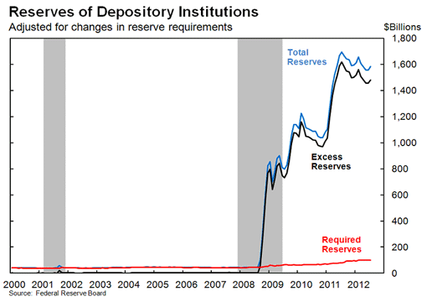

**Money Multiplier for M1:**

The simplest definition of money supply $M1$ is the total amount of currency $CU$ and checking or demand deposits (*non-interest earning) $D^{C}$* held by households and firms.

$$M^{S}=M1=CU+D^{C}$$

**Components of Money Multiplier:**

$c=\frac{CU}{D^{C}}$ is currency ratio set by privates:

$e=\frac{ER}{D^{C}}$ is excess reserve ratio set by banks

$t=\frac{D^{T}}{D^{C}}$ is time deposits ratio to demand deposits set by privates

$rr=\frac{RR}{D^{C}}$ is required reserve ratio is set by central bank

Under the following descriptions, from equations *13b* and *6* money supply can be defined in equation 14

$$MB=C+RR+ER=\left(c+rr+e\right)D^{C}$$

$$M^{S}=M1=CU+D^{C}=\left(c+1\right)D^{C}$$

$$M^{S}=M1=μ_{1}MB$$

$$\left(c+1\right)D^{C}=μ_{1}\left(c+rr+e\right)D^{C}$$

$$μ_{1}=\frac{1+c}{c+rr+e}$$

$$M^{S}=M1=\frac{1+c}{c+rr+e}MB$$

**Mishkin (2013, s. 312)assumes that the desired holdings of currency *CU* and excess reserves *ER* grows proportionally with chequable deposits $D^{C}$** ; **moreover, banks hold a fixed proportion of chequable deposits into required reserves *RR*. In other words, he assumes that the ratios of these items to chequable deposits are constants in equilibrium.**

$μ_{1}$ is a function of the currency ratio set by privates *c*, the excess reserves ratio set by banks *e*, and the required reserve ratio *r* set by the central bank.

**Factors That Determine the Money Multiplier.**

The money multiplier and the money supplyare negatively related to the required reserve ratio ***rr***.

When ***e***rises, the denominator of the money multiplier rises, and so the money multiplier must fall.

Next what happens to the money multiplier when depositor behavior causes *c* toincrease with all other variables unchanged? An increase in *c* means that depositorsare converting some of their checkable deposits into currency.

$$\frac{∂μ_{1}}{∂c}=\frac{rr+e+c-\left(1+c\right)}{{\left(rr+e+c\right)}^{2}}=\frac{rr+e-1}{{\left(rr+e+c\right)}^{2}}$$

If the condition of $rr+e<1$ is satisfied any increase in currency ratio would cause adecrease in multiplier (Mishkin, 2004, s. 379).

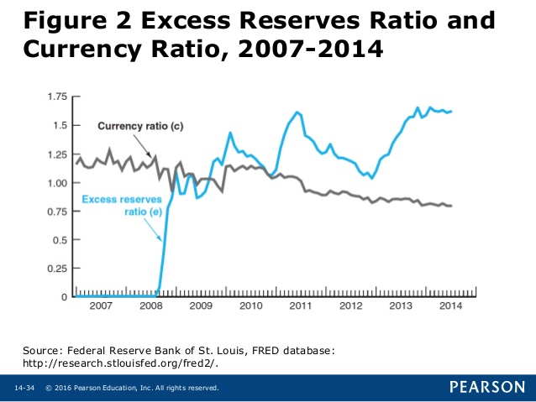

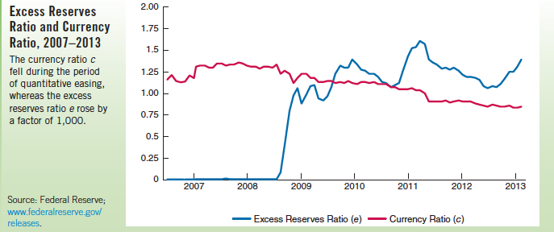

**Policy Tools of Central Bank to Manage Money Supply**

While the $rr$, $c$, $e$ are constant, money multiplier could be considered as a constant coefficient hence money supply can be managed through the **monetary base** by the CB (central bank). Also it is supposed that components of the monetary base $L^{CB}$ (indirectly through the discount/policy rate) and $B^{CB}$ (directly) are determined by CB.



# IMF DATA

# What is the discount rate?

# Discount Rate is the interest rate at which the central bank lends to commercial banks to meet their liquidity needs.

# What is the Central Bank policy rate?

The central bank policy rate (CBPR) is the rate that is used by central bank to implement or signal its monetary policy stance. It is most commonly set by the central banks’policy making. For instance, in some countries the CBPR is the **discount rate** while in others it is a **repurchase agreement rate**.

According to do **Taylor’s Rule**, policy rate will be set as response function

$$i^{P}=r+π^{e}+δ_{1}\left(π-\overline{π}\right)+δ_{2}\left(\frac{Y-\overline{Y}}{\overline{Y}}\right)$$

**Fourth Policy Tool of Central Bank: Interest on Excess Reserves**

$$M^{S}=\frac{1+c}{rr+e\left(i^{ER}\right)+c}\left[L^{CB}\underset{-}{\underbrace{\left(i^{P}\right)}}+B^{CB}\right]$$

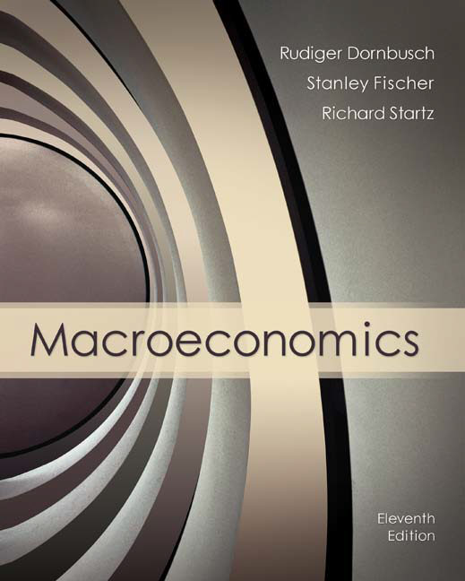Until 2008 reserves paid no interest in the United States, although other countries did pay interest on reserves. In October 2008, the Federal Reserve began to pay interest on banks’ **reservedeposits** at the Fed. The rationale is that paying interest on reserves wouldencourage banks to hold additional reserves, instead of trying to keep their reservesas low as possible.In thisway, paying interest on excess reserves gives the Fed an extra tool for setting interest rates.Under the new rules interest is also paid on required reserves at a rate just underthe targeted federal funds rate. This reduces the opportunity cost gap between whatbanks earn on required reserves and what could be earned if they were allowed to loanthe funds in the open market.

Banks hold reserves primarily because the Federal Reserve requires them to. In addition to these required reserves, **banks hold some excess reserves in order to meet unexpected withdrawals**. Because reserves earn little interest, banks try to minimize excess reserves. When market interest rates are high, banks try especially hard to keep excess reserves to a minimum. During the Great Recession, excess reserves rose massively as banks were afraid to make risky loans. Thisextremely rare event dramatically changed the money multiplier

In fact, banks increased their reserves so much that by the summerof 2009 their reserves exceeded their transactions deposits.Not only did the move to paying interest on reserves lead banks to hold substantiallymore reserves, it also gave the Fed an additional tool to use to affectthe money supply. By raising the interest rate on reserves, the Fed can encouragebanks to hold additional reserves, thus reducing the money multiplier and themoney supply. Alternatively, if the Fed wants to increase the money supply, itcan do so by reducing the interest rate it pays on reserves, causing the reservedepositratio to decline, thus increasing the money multiplier. In the financial crisis of 2008, as the Fed began offering to pay interest on reserves, the Fed thenoffset the reduction in the money supply caused by the fall in the money multiplier by increasing the monetary base. As a result, the money supply did not decline.



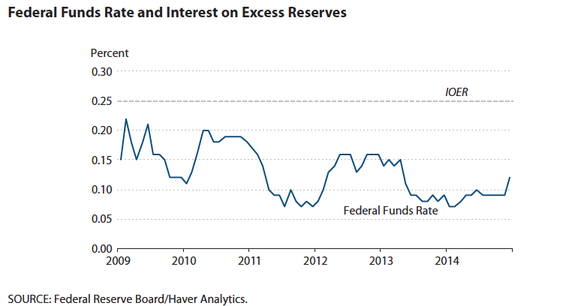

Federal funds rate must be lower, as thefederal funds rate is the opportunity cost of holding overnight reserves. But, the federal fundsrate is bounded by the discount rate and the interest rate on reserves (IOER). The upperbound is determined by the fact that financial institutions with reserve accounts can borrowfrom the Fed at the discount rate, which is sometimes treated as a separate policy instrumentby the Fed; these institutions would not borrow on the federal funds market at a rate higherthan that rate. Similarly, the lower bound is determined by the ability of financial institutionsn to lend to the Fed at the IOER; these institutions would not wish to lend on the federal fundsmarket at a lower rate.Note that “IOER” typically is used to denote “interest on excess reserves,” where excessreserves are the quantity of reserves held in excess of a bank’s reserve requirement. U.S. lawspecifies that the interest rates on required reserves and excess reserves could be different, butfor practical purposes the Fed has been setting the interest rates on both required reservesand excess reserves at 0.25 percent until 2016.

**Negative Interest Rates on Excess Reerves**

The ECB earlier in 2015 implemented an aggressive **bond-buying program**in an effort to **boost inflation**, which remains stubbornly below its target of near but just below 2%. In [June 2014](http://www.ecb.europa.eu/press/pr/date/2014/html/pr140605.en.html), the **ECB became the first major central bank to cut its deposit rate below zero**, meaning **banks must pay the central bank to hold their excess reserves (deposits.)**This deposit rate stands at -0.2%.

Central banks usually pay interest—a **deposit rate**—on commercial banks’ **excess reserves** (reserves above the minimum level). During normal times, banks usually minimize holdings in such excess reserves, because **central bank deposit rates are below typical money market rates.** In themore uncertain environment since the global financialcrisis, and with money market interest rates at very lowlevels, some banks have chosen to hold higher balancesat central banks. That is, some of them have been holdingexcess reserves because of heightened risk aversion,and because the opportunity costs of hoarding reserves—in terms of profitable lending opportunities—have been quite low, given the low returns on assetsand the sluggishness of economic activity.

A number of major central banks in Europe have set key **policy rates at negative levels**in order to further **encourage lending by making it costly for banks to hold excess reservesat their central banks**.



Amid negative policy rates, **nominal yields on some bonds of highly-rated European governments have also dropped below zero**. Some central banks are now charging (instead of paying) commercial banks for their excess reserves. **Negative deposit rates should provide some encouragement to banks to buy alternative assets, and hence to put upward pressure on prices of such assets and further downward pressure on yields and borrowing costs.**

**Negative market rates on government bonds**, particularly at the shorter end of the yield curve. For example, the 2-year bond yields on highly-rated European countries such as Austria, Denmark, Germany, the Netherlands, and Switzerland have been negative during the first half of 2015.

Besides the role of negative policyrates, there are several potential explanations for the emergence of negative yields, particularly those beyond the short-end of the yield curve. These include very low inflation, the persistence of the international “savings glut,” and further “flight to safety” toward low-risk fixed income assets. In consequence, sovereign bonds of certain countries in Europe that are deemed risk-free have been in heavy demand.



Explanations for the phenomenon of negative yields include very low inflation, further “flight to safety” toward fixed income assets in Europe’s core, and—perhaps the main proximate cause— the increased scarcity of highly-rated sovereign bonds eligible for the European Central Bank's asset purchase program. Negative rates may help boost exports by encouraging currency depreciation and may support lending and domestic demand by further easing credit conditions. At the same time, they could also have some adverse consequences for financial stability through an erosion of bank profitability, through funding problems for some non-bank financial institutions, and through excessive risk-taking by investors seeking a higher rate of return. Potential implications for developing countries include a search for yield supporting capital inflows, which could help offset the impact of an approaching liftoff in U.S. policy interest rates.

**How Interest Rates Can Go Negative**

For a long time economists believed that [nominal interest rates](https://www.investopedia.com/terms/n/nominalinterestrate.asp), were theoretically bounded by zero to the downside. Lately, however, central banks from Europe to Japan have implemented a [negative interest rate policy (NIRP)](https://www.investopedia.com/terms/n/negative-interest-rate-policy-nirp.asp) in order to stimulate [economic growth](https://www.investopedia.com/terms/e/economicgrowth.asp).

**Real Rates Can and Have Been Negative**

[Real interest rate](https://www.investopedia.com/terms/r/realinterestrate.asp), which adjusts for [inflation](https://www.investopedia.com/terms/i/inflation.asp) and accounts for the true cost of borrowing, can and has been negative before. The real rate is calculated as: real rate = [nominal](https://www.investopedia.com/terms/n/nominal.asp) rate - inflation. If the [central bank](https://www.investopedia.com/terms/c/centralbank.asp) sets the nominal rate at 1% annualized and inflation is 2% a year, the real rate would be effectively negative 1%. In other words, [the depositor has lost money by keeping it in the bank](https://www.investopedia.com/articles/investing/070915/how-negative-interest-rates-work.asp).

**Negative Nominal Rates**

The **negative nominal rates**that have been in the news as central banks seek to stimulate their sagging economies, affect a very specific rate that only impacts members of the banking or [financial system](https://www.investopedia.com/terms/f/financial-system.asp).

The central bank's **overnight interbank lending rate** is how much banks charge each other to borrow [short-term reserves](https://www.investopedia.com/terms/c/cash-reserves.asp) with the central bank acting as a warehousing facility for any [**excess reserves**](https://www.investopedia.com/terms/e/excess_reserves.asp)that the banking system cannot internally match up.

Moreover, these negative rates do not directly impact most other depositors, who have been used to very low rates of interest for nearly a decade anyhow.

The overnight interest rate is the basis for nearly every other interest rates.A negative nominal rate could serve to bring down all of those rates as well.

**The Bottom Line**

Japan now joins the [European Central Bank (ECB)](https://www.investopedia.com/terms/e/europeancentralbank.asp), Sweden, Switzerland and Denmark in enacting a [negative interest rate](https://www.investopedia.com/terms/n/negative-interest-rate.asp) policy in order to kick-start the economy. The goal is to discourage [financial institutions](https://www.investopedia.com/terms/f/financialinstitution.asp) from [hoarding](https://www.investopedia.com/terms/h/hoarding.asp) cash and instead to lend or invest it. While only specific funds held by the banking sector will be subject to paying negative interest rates, it has the potential to lower interest rates across the board making it easier to borrow money for all.

## What is a 'Negative Interest Rate Policy (NIRP)

A negative [interest rate](https://www.investopedia.com/terms/i/interestrate.asp) policy (NIRP) is an unconventional [monetary policy](https://www.investopedia.com/terms/m/monetarypolicy.asp) tool whereby nominal [target interest rates](https://www.investopedia.com/terms/t/target-rate.asp) are set with a negative value, below the theoretical lower bound of [zero percent](https://www.investopedia.com/terms/z/zero-percent.asp). During [deflationary](https://www.investopedia.com/terms/d/deflation.asp) periods, people and businesses hoard money instead of spending and investing. The result is a collapse in [aggregate demand](https://www.investopedia.com/terms/a/aggregatedemand.asp) which leads to **prices falling** even farther, a slowdown or halt in real production and output, and an **increase in**[**unemployment**](https://www.investopedia.com/terms/u/unemployment.asp)**.** A loose or [expansionary monetary policy](https://www.investopedia.com/terms/e/expansionary_policy.asp) is usually employed to deal with such economic [stagnation](https://www.investopedia.com/terms/s/stagnation.asp). However, if rate to zero may not be sufficient to stimulate borrowing and lending.

## Examples

Some examples are central bank policies. In the eurozone, in Denmark, Sweden, Switzerland and Japan, central banks have decided to have a negative rate on commercial banks' excess funds held on deposit at the central bank.

* The **Swiss government** ran a [de facto negative interest rate regime](http://snbchf.com/snb/reflections-on-negative-interest-rates-in-switzerland/) in the early 1970s to counter its [currency appreciation](https://www.investopedia.com/terms/c/currency-appreciation.asp) due to investors fleeing inflation in other parts of the world.
* **In**[**2009 and 2010 Sweden and in 2012 Denmark**](http://www.wsj.com/articles/negative-interest-rates-yield-positive-resultsso-far-1425489466)**used negative interest rates to stem**[**hot money flows**](https://www.investopedia.com/terms/h/hotmoney.asp)**into their economies.**
* In 2014 the [European Central Bank (ECB)](https://www.investopedia.com/terms/e/europeancentralbank.asp) [instituted a negative interest rate](http://www.ecb.europa.eu/home/html/faqinterestrates.en.html) that only applied to [bank deposits](https://www.investopedia.com/terms/b/bank-deposits.asp) intended to prevent the [Eurozone](https://www.investopedia.com/terms/e/eurozone.asp) from falling into a [deflationary spiral](https://www.investopedia.com/terms/d/deflationary-spiral.asp).
* On January 29th, for the first time in its history, the central bank adopted negative interest rates as a way of dealing with the threat of deflation. Japan’s central bank cut the interest rate on bank reserves to -0.1%

**Almost a quarter of the world’s GDP now comes from countries with negative rates.**The aim in the eurozone is to stimulate economic growth and to raise inflation, which is also below zero and even further adrift of the European Central Bank's target of below but close to 2%. In Sweden too, [it is about raising inflation](http://www.riksbank.se/en/FAQ/Monetary-policy/Governor-Stefan-Ingves-what-does-the-decision-on-a-negative-repo-rate-entail-/)

|  |  |
| --- | --- |
|  |  |

**Determining the Interest Rate: Central Bank can determine money supply**

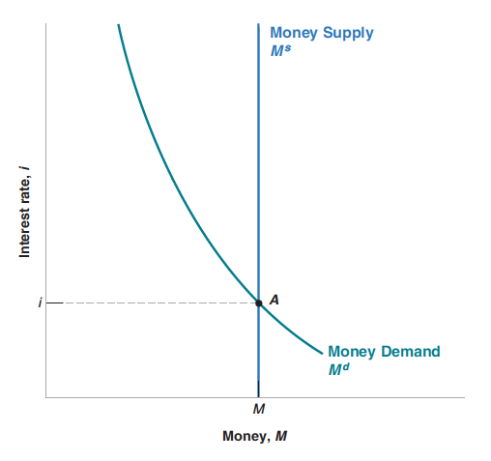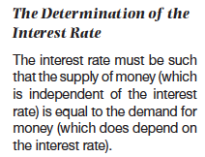



|  |  |
| --- | --- |
|  |  |
|  |  |

**Determining the Interest Rate: Central Bank can determine monetary base (central bank money)**

We took a shortcut in assuming that all money in the economy consisted of currency supplied by the central bank. In the real world, **money includes not only currency but also checkable deposits** (at least). Checkable deposits are supplied not by the central bank but by (private) banks. In this section, we reintroduce checkable deposits and examine how this changes our conclusions. Let me give you the bottom line: Even, in this more complicated case, by changing the amount of central bank money, the central bank can and does control the interest rate. To understand what determines the interest rate in an economy with both currency and checkable deposits, we must first look at what banks do.Modern economies are characterized by the existence of many types of financial intermediaries— institutions that receive funds from people and firms and use thesefunds to **buy financial assets** or to **make loans** to other people and firms.

The assets ofthese institutions are the financial assets they own and the loans they have made. Theirliabilities are what they owe to the people and firms from whom they have receivedfunds.

Banks **receive funds** from people and firms. At any point in time, people and firms can write checks, use a debitcard, or withdraw funds, up to the full amount of their account balances. Theliabilities of the banks are therefore equal to the value of these checkable deposits.

Banks keep as reserves some of the funds they receive. They are held partly in cash and partly in an account the banks have at the central bank, which they can draw on when they need to.

**Banks hold reserves for three reasons:** On any given day, some depositors withdraw cash from their checking accounts, whereas others deposit cash into their accounts. There is no reason for the inflows and outflows of cash to be equal, so the bank must keep some cash on hand. In the same way, on any given day, people with accounts at the bank write checks to people with accounts at other banks, and people with accounts at other banks write checks to people with accounts at the bank. What the bank, as a result of these transactions, owes the other banks can be larger or smallerthan what the other banks owe to it. For this reason also, the bank needs to keep reserves. The first two reasons imply that the banks would want to keep some reserves even if they were not required to do so. But, in addition, banks are typically subject to **reserve requirements, which require them to hold reserves in some proportion oftheir checkable deposits**. In the United States, reserve requirements are set by theFed. In the U.S. banks are required to hold at least 10% of the value of the checkabledeposits. They can use the rest to make loans or buy bonds.

The assets of the central bank are the bonds it holds. The liabilities of the central bank are the money it has issued, central bank money. The new feature, relative to previous, is that not all of central bank money is held as currency by the public. Some of it is held as reserves by banks.

|  |  |
| --- | --- |
|  |  |

**The demand for central bank money is now equal to the demand for currency by people plus the demand for reserves by banks. On the other hand the supply of central bank money is under the direct control of the central bank. The equilibrium interest rate is such that the demand and the supply for central bank money are equal.**

**Loanable Funds Theory and an Alternative Methodfor Interest Rate Determination**

Aspects of the **loanable funds market,** which show **how saversare matched with borrowers.** In aclosed economy, savings is equal to national savings. In an open economy, savingsis equal to national savings plus capital inflow. At any given time, however,savers, the people with funds to lend, are usually not the same as borrowers, thepeople who want to borrow to finance their investment spending. How are savers and borrowers brought together?

Savers and borrowers are matched up with one another in much the same way producers and consumers are matched up: through markets governed by supply and demand.



To do this, it helps to consider a somewhat simplified version of reality. There are a large number of different financial markets in the financial system, such as the bond market and the stock market. However, economists often work with a simplified model in which they assume that there is just one market that brings together those who want to lend money (savers) and those who want to borrow (firms with investment spending projects). This hypothetical market is known as the

1. It could be negatively related with real interest rates $r$. When the real interest rate is higher, the real return to saving is also higher, and so you will spend less and save more.
2. For example the **nominal quantity of money** is in terms of units of currency, like $50 billion. Liquidity preference theory, however, examines the **demand for money in terms of the real goods and services** it can buy. So, for example, if the price level doubled, the same $50 billion would only buy half as many goods.